Exercise 1

1. Create the following screen layout. Use the write() methods to output the text.

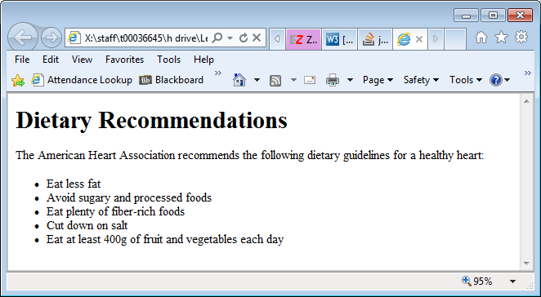

Exercise 2

**Referencing web pages:**

1. Create a script section directly before the closing head tag of the file.
2. Inside this script create 5 variables called:
   1. vegetarian
   2. hawaiian
   3. meatLovers
   4. theWorks
   5. fourCheese
3. Copy the contents from the supporting data file to initialise the variables.
4. Move your cursor directly after the following section

<p>

Click the buttons for a description of each pizza.</p>

1. Here create a form called pizzaList with the action set to “” and the method set to “get”.
2. Inside this form create 5 radio buttons with the name attribute of each set to “pizzas”.
3. Each of the radio buttons should include an onclick event handler that assigns the value of the associated variable (that you created earlier) to a <textarea> element named pizzaDesc (which you will create next).
4. Label each radio button appropriately.
5. Create a <textarea> element next called pizzaDesc. This will display the pizza descriptions (the contents of the variables you created earlier) one at a time depending on what radio button is clicked. This <textarea> should be 75 columns wide, 20 rows deep with the following inline styles set:
   1. background-color:Transparent;
   2. border:none;
   3. overflow:hidden;
   4. font:10px Tahoma;
   5. color:#3F3F3F;
6. Save and run the file.

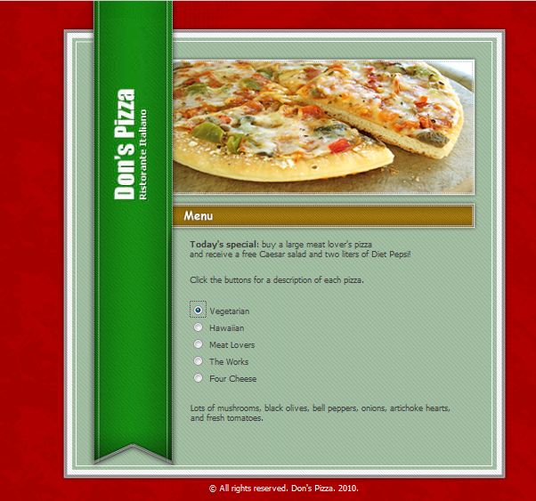

1. Can you add the text “**Todays special**:---“ also to the file.

Exercise 3

1. In the last example you learned how to reference form elements by appending the form name, the element name, and the value property to the document object. For example, to access the value in a textbox named firstName on a form named customerInfo, you use the following statement: document.customerInfo.firstName.value.
2. Using similar syntax, you can use the src property to dynamically change an image. For example you can access an image <img> element named productImage through its src property using the statement document.productImage.src.
3. Your Flag folder contains image files for the flags of 10 countries. Create a web page that contains a table with 2 columns in a single row.
4. In the first column, create a list of radio buttons that contains the name of each of the 10 countries.
5. In the second column display the flag of the selected country. Use onclick event handlers to display the flag image for each selected country.
6. When the page first loads, the image should be blank.
7. Save the page as flags.html

Exercise 4

In this exercise I want you to create a web page that contains a list of news headlines in a list box. When the user clicks a headline, the associated story will display in a <textarea> element. I want you lay out the page in a similar manner to the previous example.

The data file for this exercise is called data headlines.txt. This exercise will only work in Firefox as IE does not support event handlers in the option element.

On a side note regarding CDATA sections:

|  |  |
| --- | --- |
|  | 1. When browsers treat the markup as XML:   <script>  <![CDATA[  ...code...  ]]>  </script>   1. When browsers treat the markup as HTML:   <script>  ...code...  </script>   1. When browsers treat the markup as HTML and you want your XHTML 1.0 markup (for example) to validate.   <script>  //<![CDATA[  ...code...  //]]>  </script> |